**TASK LIST.**

1. 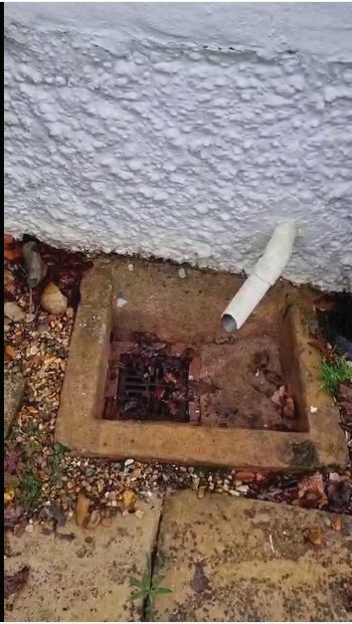The drain should be extended from the house before it gets blocked by the leaves that drop frequently. And leave blocked somehow

STORAGE

1. The 2 luggage rackss need to be taken out of the side and the shade to be cleaned then

rea�ached to the woods a�er to have excellent racks. HOW TO CLEAN THEM >?

1. Be careful not to damage the wood so use what kind of wood screws

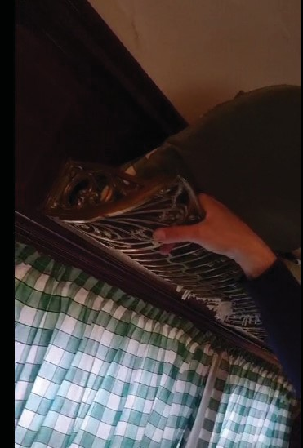

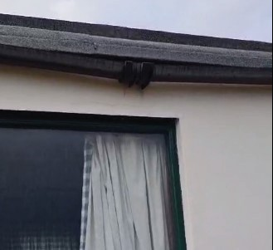FRONT OF THE HOUSE

* 1. The front of the shed on the road needs pain�ng and wood restaining
  2. The gate need reinser�ng, replacing, oiling and staining
  3. 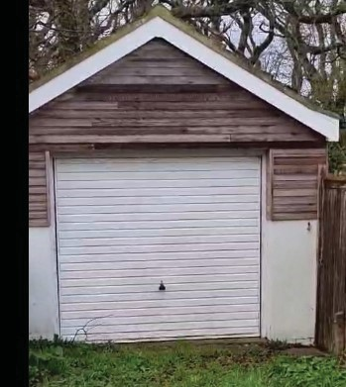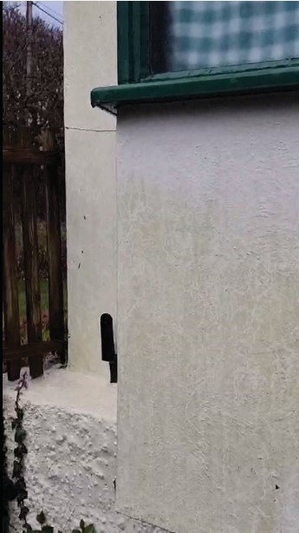The garage door need pain�ng (sanding, white undercoat and matt)

1. The “SANTOS” sign needs to be replaced with a proper “O” or replaced to have something else from the inside.
2. The external cracks need to be open, filled and pained over
3. 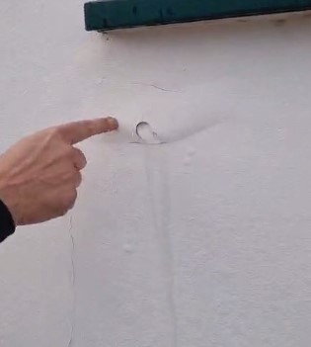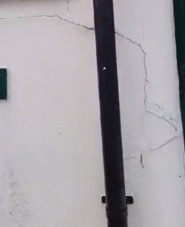The water pipe up should be rea�ached properly to the property with a ladder and resealed or attached to the propertyy

THE STORE

* 1. The door should be removed and planed down to close properly if possible.
  2. The side wall needs to be repainted.
  3. And the roof needs to be checked for leakage
  4. A �le needs to be replaced when you go through the small wooden gate. 1 x tile
  5. And the wall on that side too has a crack that should beopen fixed and repainted.

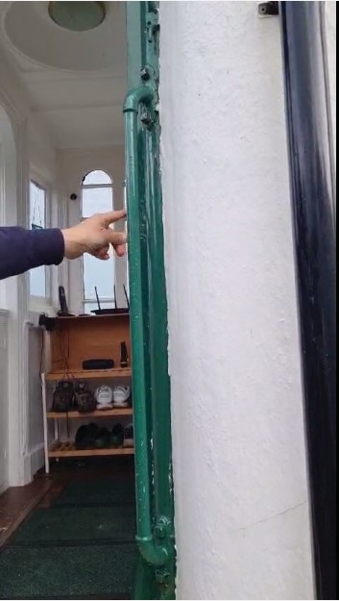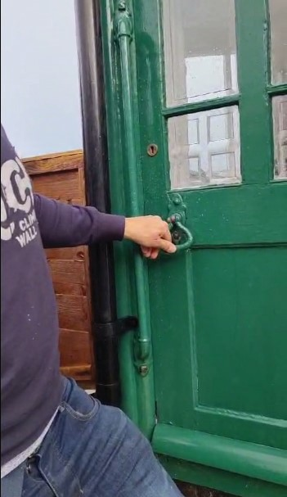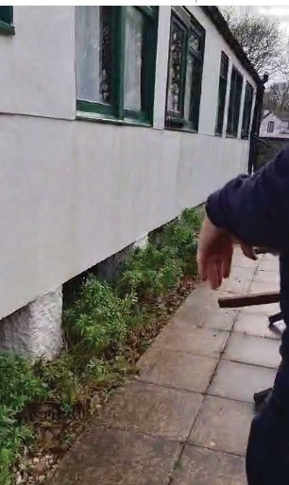

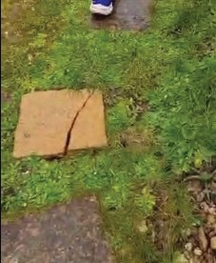 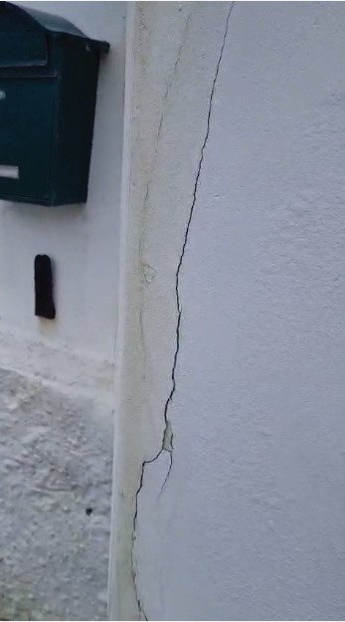

KITCHEN

1. Remove the water heater tap on the wall and remove the pipes
2. The ceiling need to be stripped of crakcs, needs to be treated and taken down.
3. The oven is old, it should be removed or replaced.with a new electic oven
4. The small side room requires having the ﬂoor repainted and cleaning up and down.and revarnishing
5. The ceiling lamp in the small room should be cleaned and the crack on the wall should be ﬁxed./ alcove

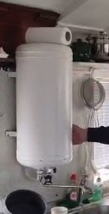 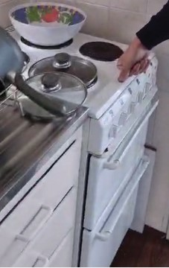 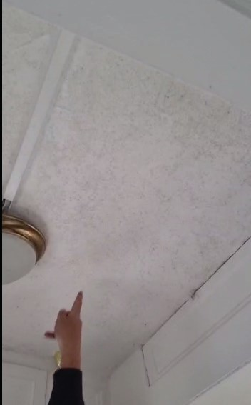

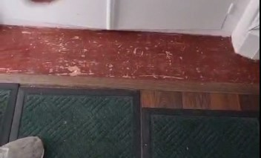 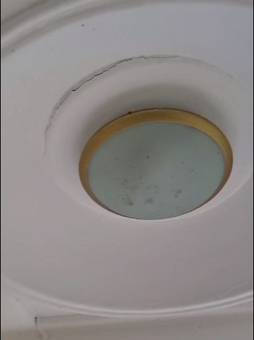

LOUNGE

1. Has a cracked ceiling that needs to be examined.
2. The sofa bed should be taken out and replaced with something diﬀerent. ?
3. 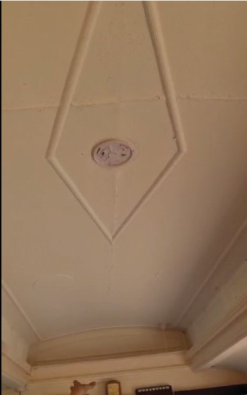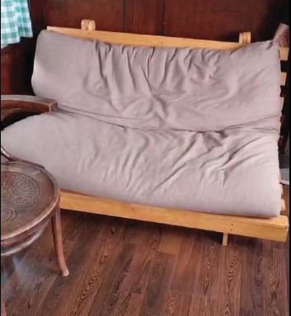The curtain rail needs to be straightened.

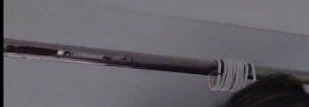BEDROOM

* 1. The bed single should be replaced.with better storage bed
  2. The ma�ress too should be replaced.
  3. The minor cracks on the roof should be looked at.

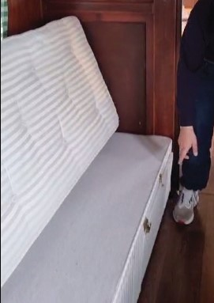

BARTHROOM

1. Has wet boards that need to be taken out and the whole sec�on taken out and repainted. With marine ply
2. Get new shower rails. X 2
3. Sand out the ro�ng floor or clean it up.
4. The mirror needs to be cleaned in general.
5. 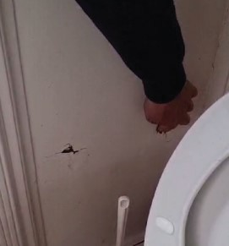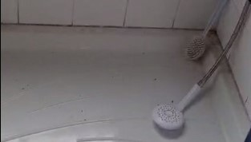A STANDING EXTERNAL SHOWER SHOULD BE FITTED

SAUNA

Windsuring racking should be taken down

Sauna to be install, with foundation (? Pallet stacks or levelling,) installed with board installation and have a roof created for rainfall and leaves , have a sauna heater installed and be weather proofed possibly with exterior varinish and sealed from elements (eg to prevent bugs etc)(

New vertical windsuring racking to be created in wood to the right of the suauna

1. **Assess the Location:**
   * Choose a suitable location outdoors for your sauna. Ensure there's enough space and proper ventilation.
   * Consider factors like sunlight exposure, wind protection, and privacy.
2. **Waterproofing:**
   * Since outdoor saunas are exposed to the elements, it's crucial to waterproof the structure thoroughly.
   * Apply waterproof sealant or paint to all wood surfaces, including walls, ceiling, and benches.
   * Seal any gaps or joints where water could penetrate.
3. **Insulation:**
   * Check the existing insulation in the sauna. It may need to be upgraded for outdoor use to maintain heat efficiency.
   * Use high-quality insulation materials suitable for outdoor environments.
4. **Weatherproofing:**
   * Install weatherproof doors and windows if your sauna has them.
   * Consider adding a canopy or roof overhang to provide additional protection from rain and snow.
5. **Exterior Finishing:**
   * Choose exterior-grade materials for any new additions or modifications.
   * Opt for weather-resistant wood, such as cedar or redwood, for any outdoor-facing surfaces.
6. **Foundation:**
   * Ensure the sauna has a stable and level foundation. Consider using concrete, paving stones, or a wooden deck as a base.
7. **Ventilation:**
   * Ensure proper ventilation to prevent moisture buildup and mold growth.
   * Install vents or louvers to allow for air circulation while maintaining privacy.
8. **Electrical Considerations:**
   * If your sauna requires electrical wiring, ensure it's installed safely and meets outdoor electrical code requirements.
   * Use weatherproof outlets and switches, and consider installing a ground fault circuit interrupter (GFCI) for added safety.
9. **Protection from Pests:**
   * Take measures to prevent pests like insects and rodents from entering the sauna.
   * Seal any gaps or cracks where pests could enter, and consider using screens on windows and vents.
10. **Accessories and Maintenance:**
    * Consider adding outdoor-friendly accessories like towel racks, lighting fixtures, and seating.
    * Regularly inspect and maintain the sauna to ensure it remains in good condition and continues to function effectively.

By following these steps, you can convert your indoor sauna into an outdoor oasis where you can relax and enjoy the benefits of sauna therapy in the comfort of your own backyard.

POSSIBLY REPLACE SHOWER

<https://www.amazon.co.uk/Triton-Collection-9-5kW-Electric-Shower/dp/B00BYWSGIQ/ref=sr_1_8?crid=9ZKOIP3CGFQX&dib=eyJ2IjoiMSJ9.ZzNDOi7WxPyYcURTxepqo9uuVDX1Egf7L_lbEP4eNrzc8S_ielaHrCf4BYMO6pwW8h9ZFep606FyBf2Sh9nwJ3Dvk-MjtijN6g6uvyy5r2yJNO5iiyuwwaXhxvp5WkSaEAigcXNKB20D95rsc0qjyh-NS6r5v-ODJaOrn_EvKczuzCRT2keq7TeEkgP45ss60d1U_GkmrTs2jrdl7usY6E1CYDraKD8Paqf5VwwWxkR_V8rgWbosLUAwYUT_fgSzpvOZimZyB_IQVCvC-f0jW-PdYJndSQCbJIdCgGEHPdU.PY6R45g20w4DfDSmlrx0Kg-uZisq0lvKrrFWpXkWnBw&dib_tag=se&keywords=electric%2Bshower&qid=1711262628&sprefix=electric%2Bshower%2B%2Caps%2C232&sr=8-8&ufe=app_do%3Aamzn1.fos.d7e5a2de-8759-4da3-993c-d11b6e3d217f&th=1>